ASSIGNMENT 3

LINK:<http://tpcg.io/_TET0VC>

PROGRAM:

public class Test { public static void main(String args[]) { int [] numbers = {34, 28, 94, 44, 53};

for(int x : numbers ) { System.out.print( x );

System.out.print(",");

}

System.out.print("\n");

String [] names = {"LAVANYA", "JANNU", "VICKY", "PRIYA"}; for( String name : names ) {

System.out.print( name );

System.out.print(",");

}

}

}

OUTPUT:

34,28,94,44,53,

LAVANYA,JANNU,VICKY,PRIYA, SCREENSHOT:

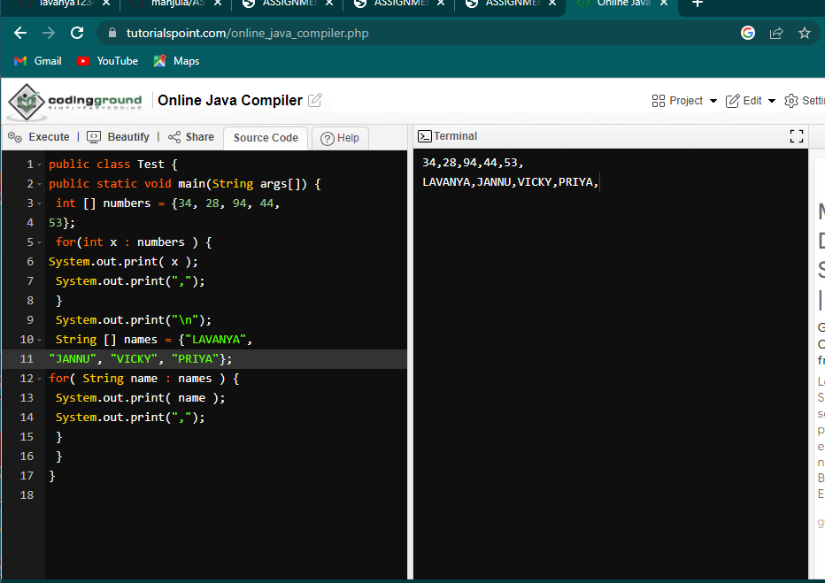

# PROGRAM SCREENSHOT